# Parking Lots Location Selection in the City of Philadelphia

IBM Applied Data Science Capstone Project Final Report

**I. Abstract**

This report is created for the fulfillment of IBM Applied Data Science Capstone Project. A business problem on the parking lots location selection strategy in the city of Philadelphia is explored using Python-driven data analysis method. By clustering the neighborhoods in West Philadelphia based on top 10 venues of each neighborhood from the “Foursquare” data, the ideal location to open a parking lot is found to be XXX.

**II. Introduction**

*2.1 Backgrounds*

The business problem explored in this report focuses on a common issue in big cities like New York, Toronto, and Philadelphia, that what would be the proper strategy to locate the parking lots. There are a couple of criteria for determining the neighborhood a parking lot should be built: First, in order to meet people’s needs, a public parking lot should target venues where people will temporary stay during the day, and avoid communities where apartments and houses have already provided enough parking spaces. Second, for the purpose of maximizing the usage of the parking spaces, the lot must be located in neighborhoods with high densities of crowds, such as shopping centers, restaurants, bus/train stations, and airports.

*2.2 Stakeholders*

The stakeholders of this report will be individuals or companies who is seeking to construct or investigate a parking lot in cities like Philadelphia.

**III. Data selection**

This project will first acquire a list of boroughs and neighborhoods in the city of Philadelphia. This part of the data is available here: <https://www.philageohistory.org/rdic-images/common/help/PhilaRegions.cfm>. A complete .csv list of borough and neighborhoods in the city of Philadelphia is available in the Github repository: <https://github.com/ZombieWonder/Applied-data-science-capstone-project.git>.

For simplicity, we will only analyze the neighborhoods in West Philadelphia as this borough has many neighborhoods with various features to be studied such as universities, train stations, restaurants, hotels, and apartments. Since the analysis method is generalizable for other boroughs, similar study can be carried out on other boroughs if interested in the future.

The neighborhood list of West Philadelphia is shown as follows:

**Table 1. List of neighborhoods in West Philadelphia.**

|  |  |  |  |
| --- | --- | --- | --- |
| Index | Neighborhoods | Latitude | Longitude |
| 1 | Belmont District | 39.96667 | -75.205 |
| 2 | Black Bottom | 39.9574 | -75.1978 |
| 3 | Carroll Park | 39.973 | -75.236 |
| 4 | Cathedral Park | 39.973 | -75.236 |
| 5 | Cedar Park | 39.947 | -75.216 |
| 6 | Cobbs Creek | 39.95291 | -75.2359 |
| 7 | Dunlap | 39.961 | -75.222 |
| 8 | Garden Court | 39.95194 | -75.2186 |
| 9 | Haddington | 39.96139 | -75.2419 |
| 10 | Haverford North | 39.9653 | -75.2066 |
| 11 | Mantua | 39.964 | -75.194 |
| 12 | Mill Creek | 39.966 | -75.216 |
| 13 | Overbrook | 39.988 | -75.25 |
| 14 | Overbrook Park | 39.977 | -75.265 |
| 15 | Overbrook Farms | 39.98639 | -75.2536 |
| 16 | Parkside | 39.97389 | -75.2067 |
| 17 | Powelton Village | 39.95972 | -75.1903 |
| 18 | Saunders Park | 39.959 | -75.199 |
| 19 | Spruce Hill | 39.954 | -75.21 |
| 20 | Squirrel Hill | 39.945 | -75.213 |
| 21 | University City | 39.95361 | -75.1986 |
| 22 | Walnut Hill | 39.956 | -75.219 |
| 23 | Woodland Terrace | 39.94889 | -75.2053 |
| 24 | Wynnefield | 39.989 | -75.233 |
| 25 | Wynnefield Heights | 40.002 | -75.209 |

The coordinates of each neighborhood are acquired from the Wikipedia. These coordinates will then be used to call Foursquare and get the top 10 venues of each neighborhood.

**IV.** **Experiment method**

With the neighborhood coordinates downloaded from Wikipedia (Geocoder database, as mentioned in Week 3’s assignment instruction, is quite unreliable and does not return any results per call, although this part of the codes are still preserved in the Jupyter notebook.), these coordinates are called in Foursquare to get the top listed venues of each neighborhood. Here the top 10 listed venues are selected as features for next step clustering.

The neighborhoods in West Philadelphia will be clustered using “k means” method in “sklearn” package. Based on the results of clustering, pins representing every neighborhood will be colored differently to show its class and placed on the map of West Philadelphia. This function is realized by the “folio” package. At last, individual clusters will be examined and the results will be utilized to decide which neighborhood the parking lot will locate.

**IV. Result**

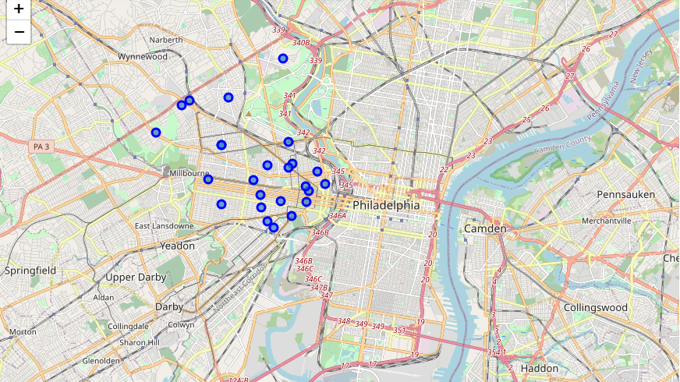

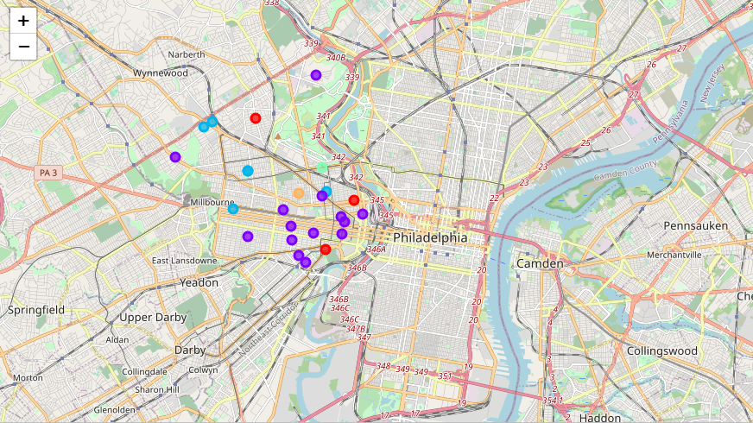

**V. Discussion**

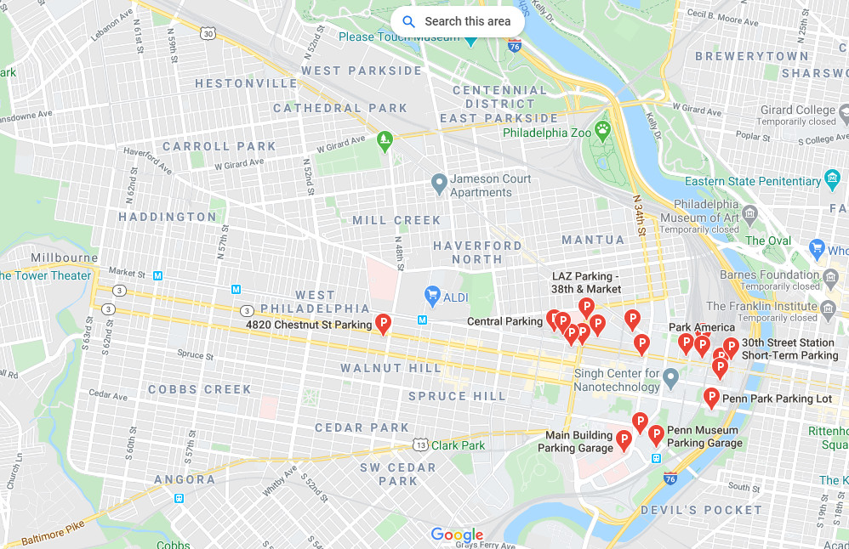

**VI. Conclusion**